### Log

For troubleshooting and examination purposes you can log all the fields. All the data coming in on each specific field can be saved to a log file.

Go to “Tools > Field Settings > Log” and choose the right field (e.g. Engine 1 Oil Pressure).

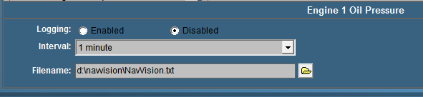

Figure 11‑22: Logging

#### Logging

Choose whether to enable or disable the logging on this field.

#### Interval

Depending on the data on the field you can choose an interval her form 1 second to 2 hours. Useless to say that the log file is getting a lot bigger at an interval of 1 second. Be very precautious when using this.

#### Filename

Here you can chose the name and place where you save the log file.

### Logging with trending

When you have mimics available, you automatically have the possibility to make a trending mimic. Trending is very useful for troubleshooting and you can also use it to log activities.

In an empty mimic make a trending instrument (see Figure 8‑15). You will get the following instrument (see Figure 11‑23). At the right side you can choose the field that you want to see in your trend-instrument.

Click with your mouse on the box at the right side of the trending window. A dialog box will appear (see Figure 11‑24). Here now you can chose the field that you want to track.

Once you have chosen a field a new box will appear. Clicking on the colored line will take you to the color adjustment window, so you can give every trend a distinct color.

Moving your mouse over the trend-lines give you an exact date and time for every event on that line (see Figure 11‑25).

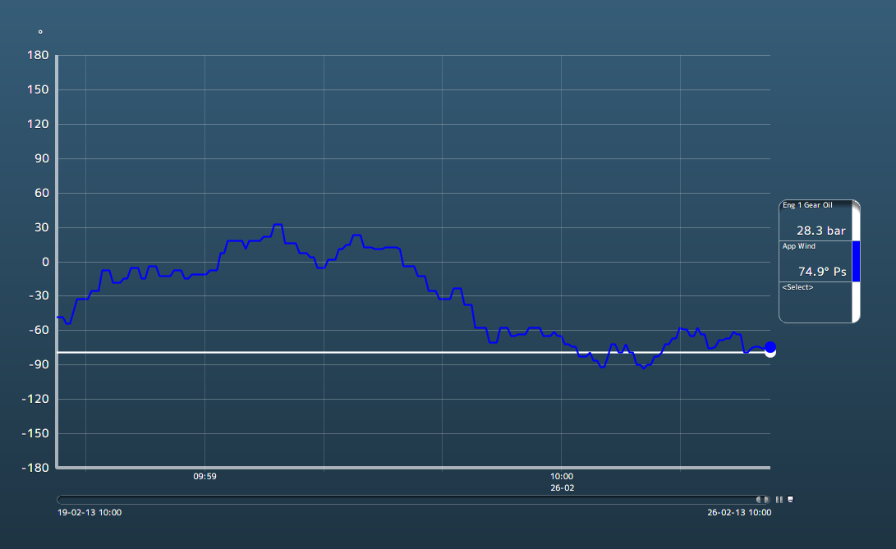

Figure 11‑23: Trending instrument

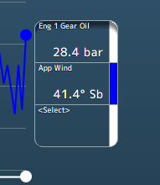

Figure 11‑24: Selection boxes

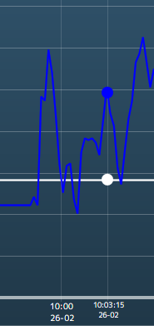

Figure 11‑25: time line

The line underneath the trending page is adjustable. You can take one of the corners to adjust the length of the trend to the interval time that you like to use (see Figure 11‑26).

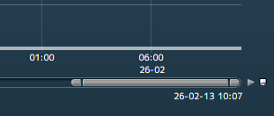

Figure 11‑26: Trending adjustments

Next to that line you can see a play button to make it interactive. You can play or pause the trending. Next to that is a save-icon. If you want to save the trending, click on the icon, find a place to save and give the file a name. FT NavVision® will save it to a .csv file that you can open with Excel (see Figure 11‑27).

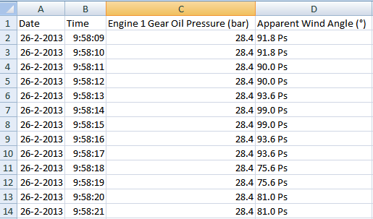

Figure 11‑27: Saved trending file